Tag Frenzy Documentation – Version 1.0

# Setting Up Tags

1. Go to Window->Tag Frenzy->Add Tags to all Scene Objects.

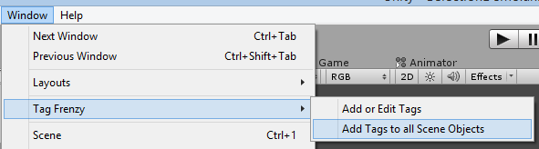

This will add the Tag Frenzy component to all objects in the scene. You can now check and uncheck tags. If you add new objects to the scene later you can re-run this action to add the Tag Frenzy component to the new objects.

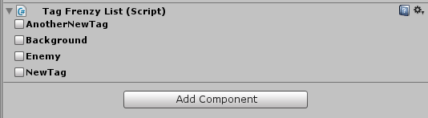

1. To edit tags, go to Window->Tag Frenzy->Add or Edit Tags. Here you can rename, add, or delete existing tags. Click ‘Save’ to save your changes, or ‘Cancel’ to leave without saving.

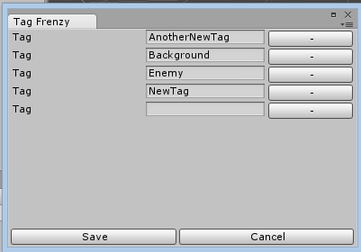

# Find GameObjects Using Tags

To find the tags programmatically, add **using TagFrenzy;** to the top of your script.

You can then call the FindGameObjectsWithTags like this:

List<GameObject> results = MultiTag.FindGameObjectsWithTags(Tags.Background, Tags.Enemy, TagMatch.Or);

**TagMatch.And -** Find objects containing all of these tags

**TagMatch.Or** - Find objects containing any one of these tags

**TagMatch.Exact** - Find objects that contain all of these tags and no others

**TagMatch.Not** - Return all tagged objects except for ones that contain any of these tags

# Retrieving Tags From GameObjects

To see what tags are on an existing GameObject, you can call one of two extension methods – either **tags()** to return a string list of tags, or **enumTags()** to return an enum list of tags.

GameObject go = new GameObject();

List<string> tags = go.tags();

List<Tags> enumTags = go.tagsEnum();

# Contact Info

If you have any additional questions, you can contact me at [neilcmeredith@gmail.com](mailto:neilcmeredith@gmail.com)